MDD_COM_GVDM-MLT_OSW Application Software Installation

Operating System Installation
The software is designed to run on Windows 11 Pro. Before proceeding, ensure that all computers provided by the manufacturer are equipped with the correct operating system.

GVDM Application Installation Steps
The GVDM installer automates the following steps to set up the application:

Pre-Installation Cleanup

If a previous version of the GVDM application is detected, the installer uninstalls it and removes all associated directories.

Directory Structure Creation

Creates the following directories on the C: drive:

C:\GVDM

C:\GVDM\config

C:\GVDM\scripts

File Deployment

Copies the following files to their respective directories:

GVDM.exe to C:\GVDM

npcap-1.80.exe to C:\GVDM

Packet.dll and wpcap.dll (required for Npcap) to C:\GVDM

gvdm_config.json (required for GVDM) to C:\GVDM\config

remove_gvdm_logs_other_than_last_ten.ps1 (required for GVDM) to C:\GVDM\scripts

Application Installation

Installs the GVDM application and creates the necessary uninstall files in C:\GVDM.

Npcap Installation

If the Npcap sniffer (required for Ethernet packet interception) is not already installed, the installer runs npcap-1.80.exe to complete the installation.

After installation, the npcap-1.80.exe file is deleted from C:\GVDM.

Shortcut Creation

Adds a GVDM folder on the desktop, including a shortcut to GVDM.exe for easy access.

GVDM Application Installation

Perform the following actions to install the application:

Open File Explorer
  - Navigate to the C: drive (or your designated drive).

Locate the Installer
  - Find the installation file, e.g. GVDM_Install_1.0.1.0.exe.

Run the Installer
  - Double-click the installation file to begin the GVDM installation process.
  - Click the "Next" button.
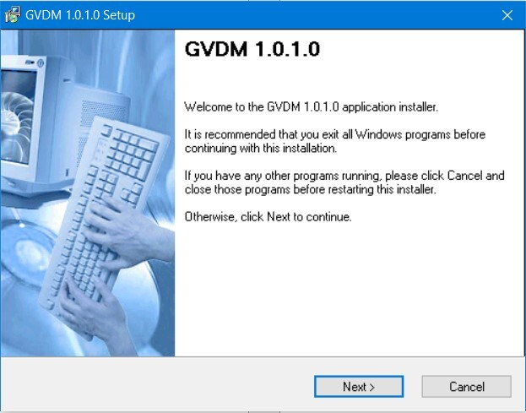
  - Click the "Next" button.
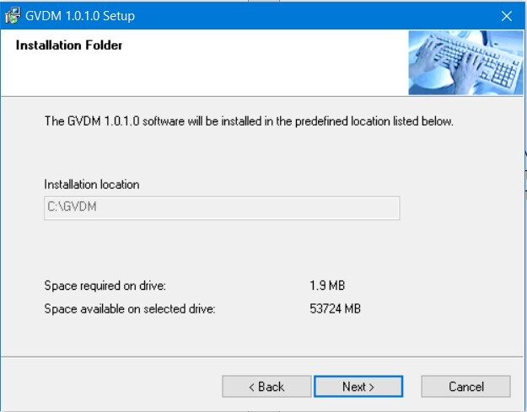

  - Click the "I Agree" button to install the Npcap software.
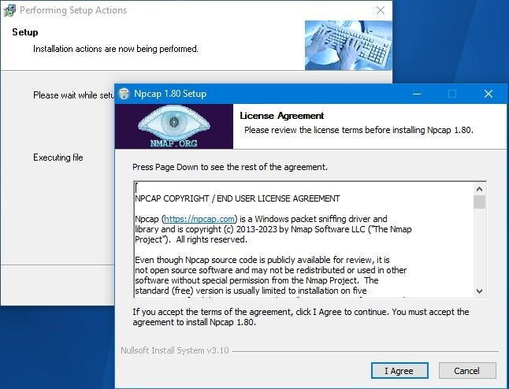

  - Click the "Install" button to install the Npcap software.
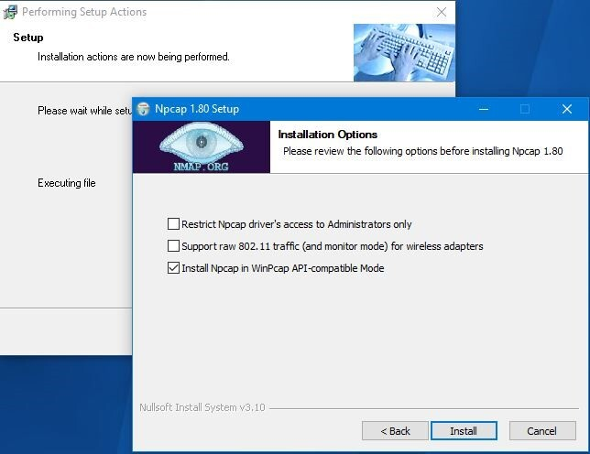

  - Click the "Next" button.
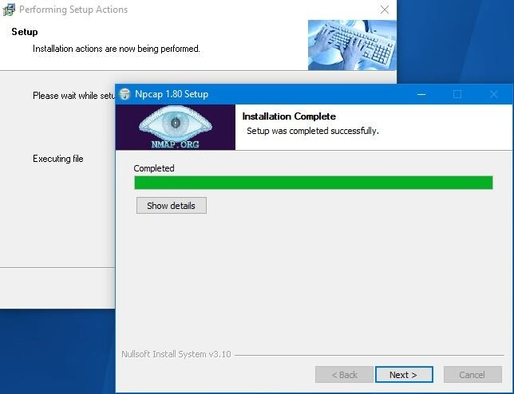

  - Click the "Finish" button to complete the Npcap software installation.
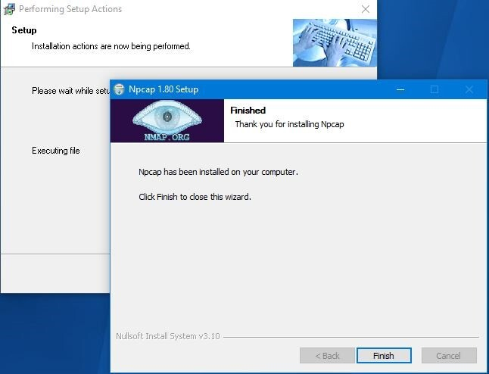

  - Click the "Next" button.
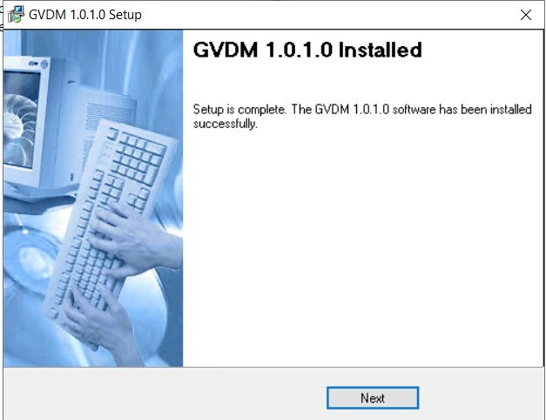

  - Click the "Finish" button to complete the GVDM software installation.
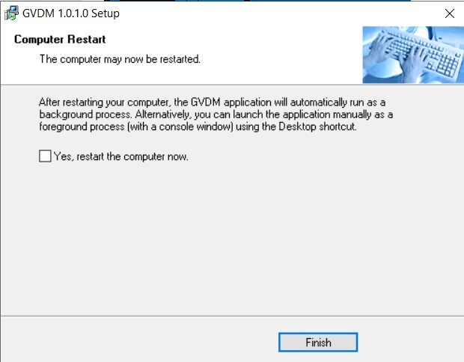

Close the File Explorer
  - Once the installation is complete, the GVDM application can be launched manually by running the GVDM.exe file. The automatic startup feature will launch the application as a background process upon system boot.

Launching Instructions
Depending on the configured settings, the Ground Video-Data Multiplexer (GVDM) application can be launched either automatically during system startup or manually via a desktop shortcut.

Automatic Launch (Default Method)
By default, the GVDM application is configured to launch automatically 20 seconds after system startup through the Windows Task Scheduler. It runs as a background process with administrative privileges and real-time priority.
Key Characteristics of the Automatic Launch Method
- Startup Behaviour
- No user login or password entry is required for the application to start.
- Operates independently of peripheral devices such as a monitor, keyboard, or mouse.

- Connectivity Requirement
- The application requires both network cables to be connected for proper functionality.
- If one or both network cards are disconnected, the application will crash. In such cases:
  - Reconnect the cables.
- Manually restart the application or reboot the system to restore functionality.

- Background Process
- The application runs silently without displaying a console window.
- To verify its operation, users should:
  - Open the Task Manager.
  - Look under the Background processes section for the Ground Video-Data Multiplexer process.

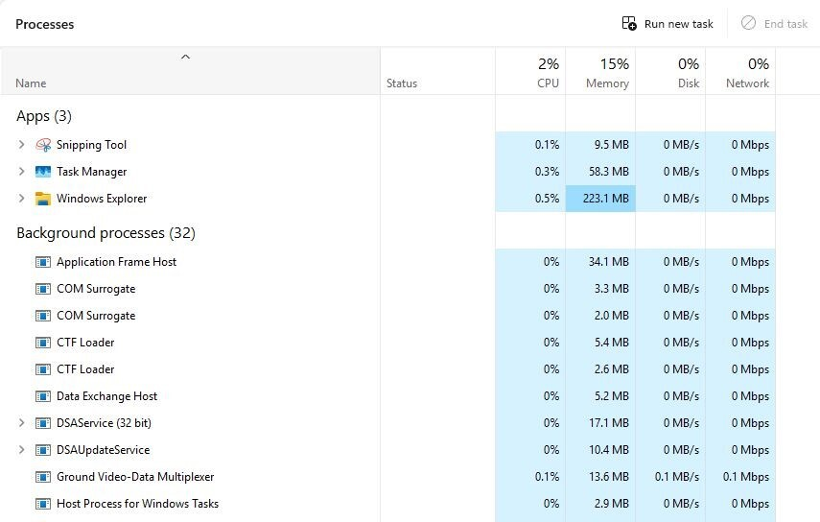

Manual Launch
The GVDM application can also be launched manually using the shortcut located in the GVDM folder on the desktop. This shortcut links directly to the application executable at C:\GVDM\GVDM.exe.
Steps for Manual Launch
- Locate and double-click the GVDM folder on the PC's desktop to open it.

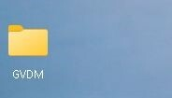

- Inside the folder, find the GVDM shortcut.
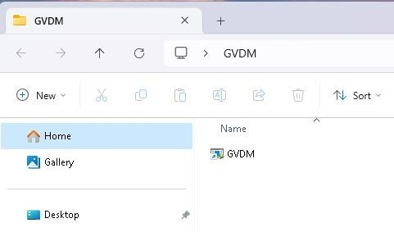

- Right-click on the shortcut and select Run as administrator from the context menu to start the application with the required privileges.

- In the User Account Control (UAC) dialogue that appears, click Yes to grant the administrative access permissions necessary for executing the application.

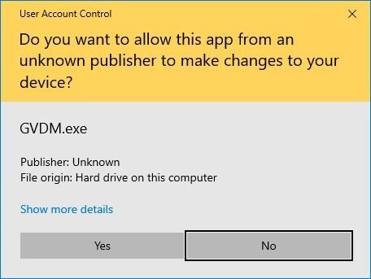

- Once launched, the application will open a console window that provides real-time visual feedback. The details displayed depend on the current logger configuration.

Instance Management
Regardless of the launch method (automatic or manual), the GVDM application enforces a single-instance policy. This ensures that only one application instance can run at any given time. Any attempts to launch additional instances will be blocked.

